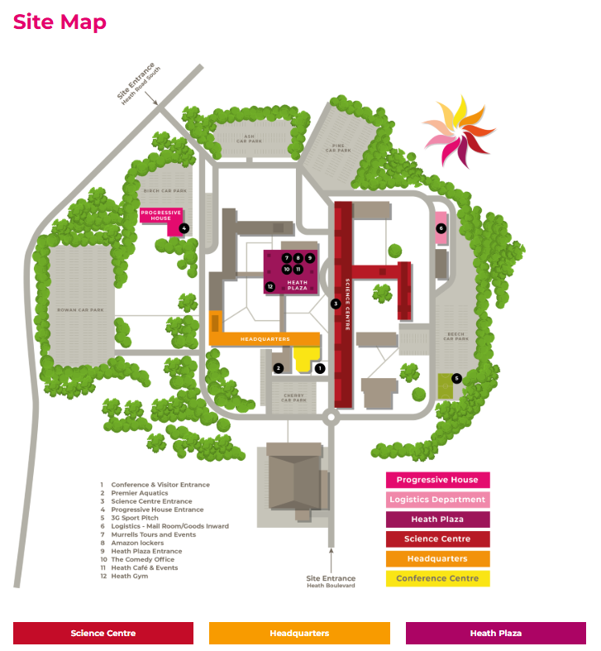
Events will take place in either The Conference Centre or our office (Room 526).
Park in the ‘Visitors Car Park’ by The Conference Centre.
If in The Conference Centre, report to the main reception desk and staff will inform you of which room we are in.
If in the office, please go the Science Centre main entrance (marked 3 on the map). Sign in and staff will buzz you through. Turn right and proceed to the stairs or lift. Go to the top floor. If coming out the lift, turn right, if using the stairs turn left. Proceed down the corridor until you reach room 526 on your right.

